**Conversation Guide: Digital Health Modernization Discovery Research - Caregiver Group**

**Bold text identify the moderator’s questions.**

*Text in italics are Jen’s observations and interpretations of the participant.*

[Text in brackets are interpretations in participants’ direct quote.]

**Background (5 minutes)**

To get started, I’d like to get a little background information about you, and your experience with the VA.

1. **Can you tell me a little bit about yourself and the Veteran you care for?**

Part of what I do is that I am a caregiver for my husband. He was hurt in 2008 and retired was 2010 after 3.5 years of active service. He wanted to be a lifer but they told him he was too injured to do so, so they retired him out on medical.

We have been dealing with the VA since 2010. There are ups and downs. A lot of pulling teeth to get medical care taken care of.

We are finally at a point where we have providers that seem to care a bit more.

The last couple years has been more of an upswing with some surgeries added in to that.

We go through surgical cycles is what we call them. We’re in a surgical castle this year. He’s had 5 procedures on one leg this year. It has been a busy one.

COVID doesn’t help with much but they are doing what they can.

Part of what I do is I manage his medications, manage his appointments. Makes sure gets to a from. He just got released back to do light driving now only if it is within 15 minutes.

Being a caregiver, I am also a mother and I run my own fitness company. I’ve been busy. I am a personal trainer but I special with people post injury, post surgery. My husband loves when I get his therapy going.

**Where are you located:**

Central South Carolina.

**How long:**

Off and on since 2011. I came here shortly after we meet then spent a couple years in Myrtle Beach then came back. We like this area.

**What’s your husbands name:**

Aaron.

1. **When did you step into the role of a caregiver?**

On our first date. *Participant laughs*. He had an episode on our first date where his medication crossed over and I ended up watching the movie on my own when he was sleeping for two hours.

I knew what I was stepping into. He was sweet. He was lucid enough to know I was there but not enough to wake up.

We meet in 2009. Started dating 2010 and then he was retired in 2010. I went through the med board process with him. Went to all his out processing as well. His issue was memory, so I was taking notes at meetings. Little did I know he was prepping me to be his wife. *Participant laughs*.

1. **Do you personally receive any benefits from the VA?**

**3.a. What VA benefits does [Veteran] receive?**

Currently he goes to outsource for surgery. He receives mental health, primary care, dental, audiology, imaging, gastro, dermatology and of course pharmacy. Oh and for his TBI he gets screenings and physical therapy occasionally. And then memory therapy as well.

So a few therapies and he’s got a few providers. *Participant laughs.* I think last time I counted he had 20 providers.

**So that’s a lot for you to keep track of:**

We have anywhere from 3-8 appointments a week.

So yeah he doesn’t work.

My business luckily I can schedule around. That’s one reason why I do what I do for work so I can schedule around his medical needs and or around our house needs.

**What other VA benefits:**

He has his retirement. He is rated with the VA so he does receive a stipend. He also receives a homebound stipend.

And we are currently in the process of reapplying for the paid caregiver program. We have been denied previously.

All of his providers say he would benefit from me being home and able to be his paid caregiver.

Me being home more means I am not able to work as much. I already limit my work hours drastically. So I only work 1-2 hours a time then take a break, check on the house, make sure everyone is taken care of. Then I might go back to work or I might be done for the day depending on how it is looking.

Our day to day is very different so it’s hard to schedule everything. It’s 9am and he is still in bed because he was probably up all night.

**You have a 4 year old and 1 year old**:

Correct. They are both boys.

**Process of applying to become paid caregiver. Can you tell me about that process**:

This new processing is a little bit different it because they changed it on Oct 1st.

Previously you would send in the application and the caregiver coordinator would call and basically approve or deny you in one call. They said it was based off of medical need as well.

The problem with my husbands medical file has been bounced around so many times that it has been filtered incorrectly into the system. So for the past 5 years I have been trying to get it corrected so all providers can see all of his medical records.

If I pull it up on Blue Button I can see everything and I will send it in with the applications.

This new round that has started is a different process. Same application, and then a call for me, a call for him, then a call together. Then we have a nursing call. Then it goes to a review board and then to decision.

So the idea behind is it is a 90 day approval phase rather than a two step yes or no. Another thing that has been opened up with is an opportunity for other illnesses being included instead of service related injuries. Everything will be included.

**Issues with providers seeing his full record. Do you know specific instances of what’s not showing up:**

When we moved back to this area the first provider that my husband saw wasn’t very good. We were very unhappy with him. We showed up, hadn’t read my husband’s records at all.

He also then filtered all my husband’s records as an outside provider so it sealed all of his previous records of 6 years as an outside provider.

So we had to get that doctor to get them resubmitted them as a VA provider transfer. And during that process a lot of the linkage was broken.

When he were filtered them back in as a VA provider he put them in the wrong file is what we were told. So they are there and accessible but people have to search for them.

Typically you should be able to click on certain diagnosis and it should pop-up so now they have to go in and search a little harder. So a quick button typically works. I have to say it’s in there, do a search, and then they can find it.

We have gone to medical records; they say it’s all there so there’s not much they can do on that side. It keeps going back to the provider who shifted them in incorrectly.

So we have been dealing with that for 3.5 years now on that side.

Before it was a transfer from a hospital to clinic. Similar issue where we basically had to resubmit all the VA records. I keep a binder and just update it. We now have three cases of folders of just updating his medical.

I have scanned in most of them so I have a PDF on my computer now. At least we can easily search it in the PDF and show them the date/time to help them search it. Because I have already electronically documented but it took 3 weeks to do that.

**You are able to see it from the Blue Button**:

I haven’t had an issue pulling them up but for some reason the providers say that they can’t.

His current primary care provider isn’t afraid to go searching.

She actually tells him to be quiet so she can talk to me. He doesn’t tell the whole truth. It’s not because he is lying but because he doesn’t remember. If he stayed up all night he forgets it. He just doesn’t remember his cyclic [?] events so she looks at me for my perspective. I really enjoy that.

I am unable to go to all appointments due to COVID and having kids. So we usually send emails back and forth if something is going on with updates. So there’s a record for her to fall back on if it needs to be tracked.

We keep little logbooks too of his day to day to fall back on incase we need the information we can go back and look at it. We call it his pocket memory. *Participant laughs*.

**It’s a paper notebook**:

Yes. We use it if he ate, his water intake, his bodily functions, if he fell, his medication. When he’s taken them; morning evening or afternoon. Which I ask him to make sure he takes them everyday.

That is one of my jobs is making sure he’s taking his medication. And to make sure he isn’t running out. He can usually fixate on one of them, but he takes 25 medications a day so its not easy to keep track of. A couple of them are multivitamins but there are ones that will help with pain. So they are kinda necessary.

**How to you email with the provider**:

I sign into My HealtheVet, or however you say that, and do the portal. I think it is a messaging portal is what they call it now.

It is pretty easy, his mental health, primary care, therapy, I email with regularly.

Mostly primary care and mental health the most. Then if we need to talk to message pharmacy we call pharmacy to get the ball rolling, then message so there’s a track record.

Just get primary care and pharmacy start talking to each other. Otherwise it can be a couple days or sometimes a couple weeks before we get medication. But if I call and email both we usually get them in a two days.

We’ve kind of figured out system that tends to work.

But now that there is a regulation that they have to answer emails within 24 hours. You might still get an automated response from the nurse. Hey I got your message, I will relay it to the doctor. But typically even when his primary’s nurse answers we will get an answer from his doctor within a day.

We have had to use patient advocate a couple times in the past year. Also through email and calling.

**Tell me about patient advocate experience:**

They [VA] kind of locked him in the hospital. The VA wouldn’t release forms to the hospital that they needed to discharge him. So the hospital was trying to discharge him post-op. He had everything else lined up. All his outside providers were lined up. The only hold up was the VA sending back the paperwork needed to be able to discharge him.

So I had to get on the phone for two days with patient advocacy and I forget the name of it. Let me look at my notes. Community Care and Community Health. Those two offices were in charge of outsourcing outside care and in home health.

They had all information they needed and sent but the proof that was supposed to send out the authorization codes, they refused to release them to the hospital. I had to call and get them, and then give them to the hospital. Rather than them releasing them right away.

So the first time that happened he ended up staying in the hospital 4 more days that the hospital wanted. The second time it happened they tried to discharge him on a Thursday he had to stay until the next Tuesday because the VA refused to release the authorization codes. This last time we preemptively filed everything before his surgery but he still got held over another day later because of the authorization codes.

They have the codes but they refuse to give them to the charge nurse or the floor staff that needs it to process the discharge paperwork.

So basically he was held at the hospital due to the VA not releasing their part. Of course when you have a viral infection you don’t want to stay in the hospital that long. It opens it up for more infections to come in.

So the surgeon was livid. The staff was livid. It took me calling Patient Advocacy and I had the code within 30 minutes I had the number. So I don’t really see what the hold up was. If they can give it to me over the phone then why cant they give it to the hospital.

So the hospital has learned if they are getting now where with the VA them they call me and I will get the ball rolling. And usually I will get it within an hour. But that is time I don’t necessarily, I will happily do it for my husband, but it was time I was sitting in the car with my kids screaming for an hour. But that is what needed to happen to get him discharged from the hospital.

Once I can kind of see. Three times gets aggravating. *Participant laughs.*

1. **Do you manage any of [Veteran's] VA benefits online?**

4**.a. Where do you do that?**

We check into ebenefits to make sure everyone is up to date.

We added the kids to DEERS, updating ID cards with DEERS programming.

Of course our medical is through Tricare so there’s that.

We have also used My HealtheVet for pharmacy and medical records.

**Ebenefits up to date. Is that for your children:**

Yes, that the beneficiaries are up to date. We went from one kid to two. Making sure they both of them are in there.

Everything used to be filtered through my father in law. But now we have it being sent to the boys and me should anything happen that we don’t want to.

Mostly just updating baseline paperwork should anything happen to Aaron what would happen to us kind of thing.

His health is going down hill so we’ve tried to make sure all ducks are in a row. Hopefully, we’ll get a long time with him.

1. **Do you use any mobile apps to manage [Veteran's] health?**

Google Calendar often. I have my work calendar. I have essentially three work calendars logged on to it. The boys calendars, his and mine all logged on. I get to see everything that is happening. He [vet] doesn’t see my work one unless it is time I cannot be around. Like this one I can sit with a my kid on my lap it’s not a big deal. But others I need a sitter or have them watch a movie.

We use do use Google Calendar to manage day to day so if somebody calls he can say I have this time open.

I used to have all the calls directed to my phone but now I’ve put some of that responsibility in his hands. Doesn’t always work out, but trying to get more in his ballpark.

We use MyCharts for his civilian medical because all that goes back to the VA. Like the outsourced surgeon goes to MyCharts. It is a link in for civilian medical providers.

**Differences between MHV an MyCharts:**

MyCharts is little more front view friendly. You can login to multiple organizations. So like right now he goes through 3 hospitals systems, and they all have their own logins. But it gives me an alert and if an appointment pops up I can pull it straight from the app into our calendar.

Like yesterday he had lab work done and it popped up into MyChart last night so I was able to see it right away.

Now I don’t always know how to read it but I can research. And if like his levels are really high I can message the doctor immediately and then there medical team will call us and say everything is ok or this is something to have a followup with.

It is nice having it right away, those lab results quickly instead of waiting 3 or 4 months later. Ok well you were really sick.

With the VA we’ve had results not even show up and them having no record he even went to the labs. Until we called and asked where the labs were. Even though the provider had requested it and it was done, it wasn’t until we called a week later that they even knew he went and a couple more weeks before the results. And at that point we had seen two other providers they didn’t know anything about looking at the labs. And then we had to call for the follow up on that one.

So the VA is a little harder to get through.

**Alert for labs on MyChart. Have you seen something like that on My HealtheVet:**

Not that I’ve seen no. But on MyChart it send you a little alarm. It doesn’t say for who, so I have go look to see who for, whether it’s on my chart, or my husbands. But typically we know who had labs so I can login to his account real quick.

The alerts are nice because it reminds you to look at them. And that things got processed through so you are not just waiting in limbo. Which I feel like we do a lot of with the VA.

**MyChart is that a separate app on the phone or use browser:**

Yes, it is a separate app. I think it has a browser option as well but it is a simple. The browser form looks a lot like and app. App front, still clickable, but the app feel to it, there isn’t much difference between visual browser and app.

I haven’t used the browser option because it is easier to do it off my phone. Right now we have 5 providers and you can add organizations as well form all around the country.

**Mental model of health at the VA (20 minutes)**

Now I’d like to ask you how you manage information and tasks related to [Veteran's] health care. For each one, talk me through the steps you’d take. If there is something that you go online to complete, I may ask you to share your screen so I can see what you would do. **(10 minutes)**

**Tasks** Moderator should prompt about device usage if participant mentions digital tools or resources.

* **How would you reach out to [Veteran's] VA care team if you had a question?**

I would most likely go to My HealtheVet and log into the messenger. I typically do it on my phone because I am already logged in. I pretty much stay logged in on my phone. That is the easiest way to get ahold of them. Otherwise you are sitting on hold from 45 minutes to an hour trying to transfer through the systems. Then they will either call us or email back for the follow up.

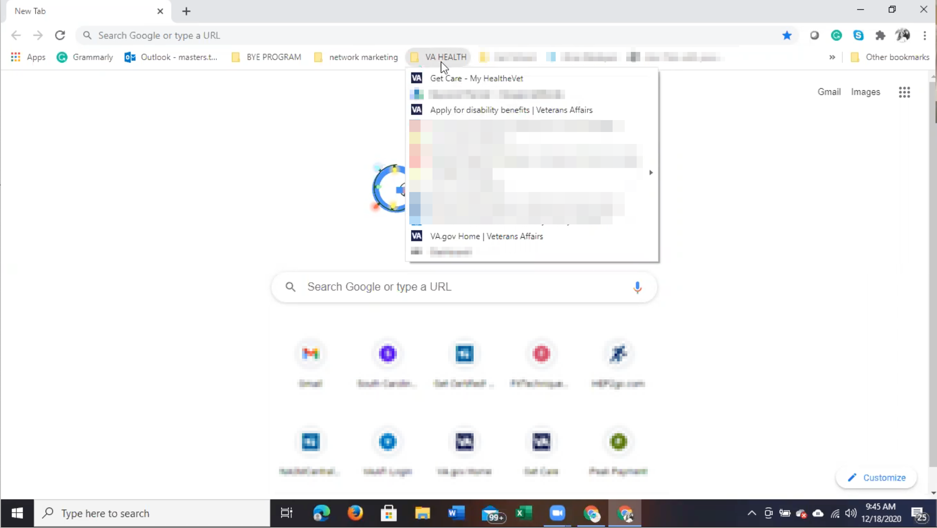

Participant shares screen. Is using Chrome browser and has VA links bookmarked including My HealtheVet.

I have VA health folder just for him. We have used join.me for some of his video appointments but some of them [bookmarks] are ones I have to go to and a few are just things that we need to remember.

I click sign in.

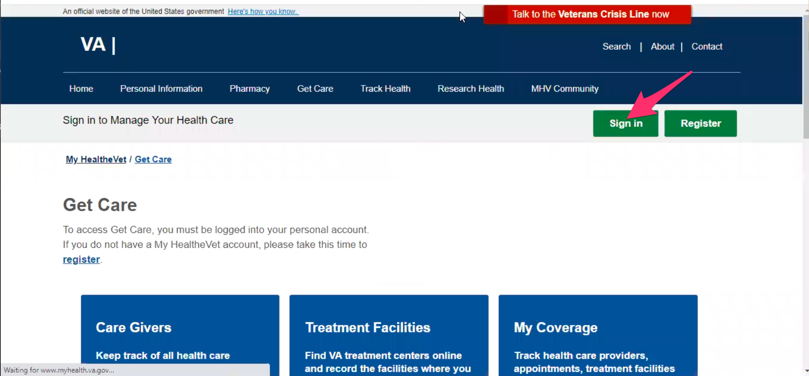

Bookmark is for Get Care page. Participant clicks on green “Sign in” button in upper right to sign in.

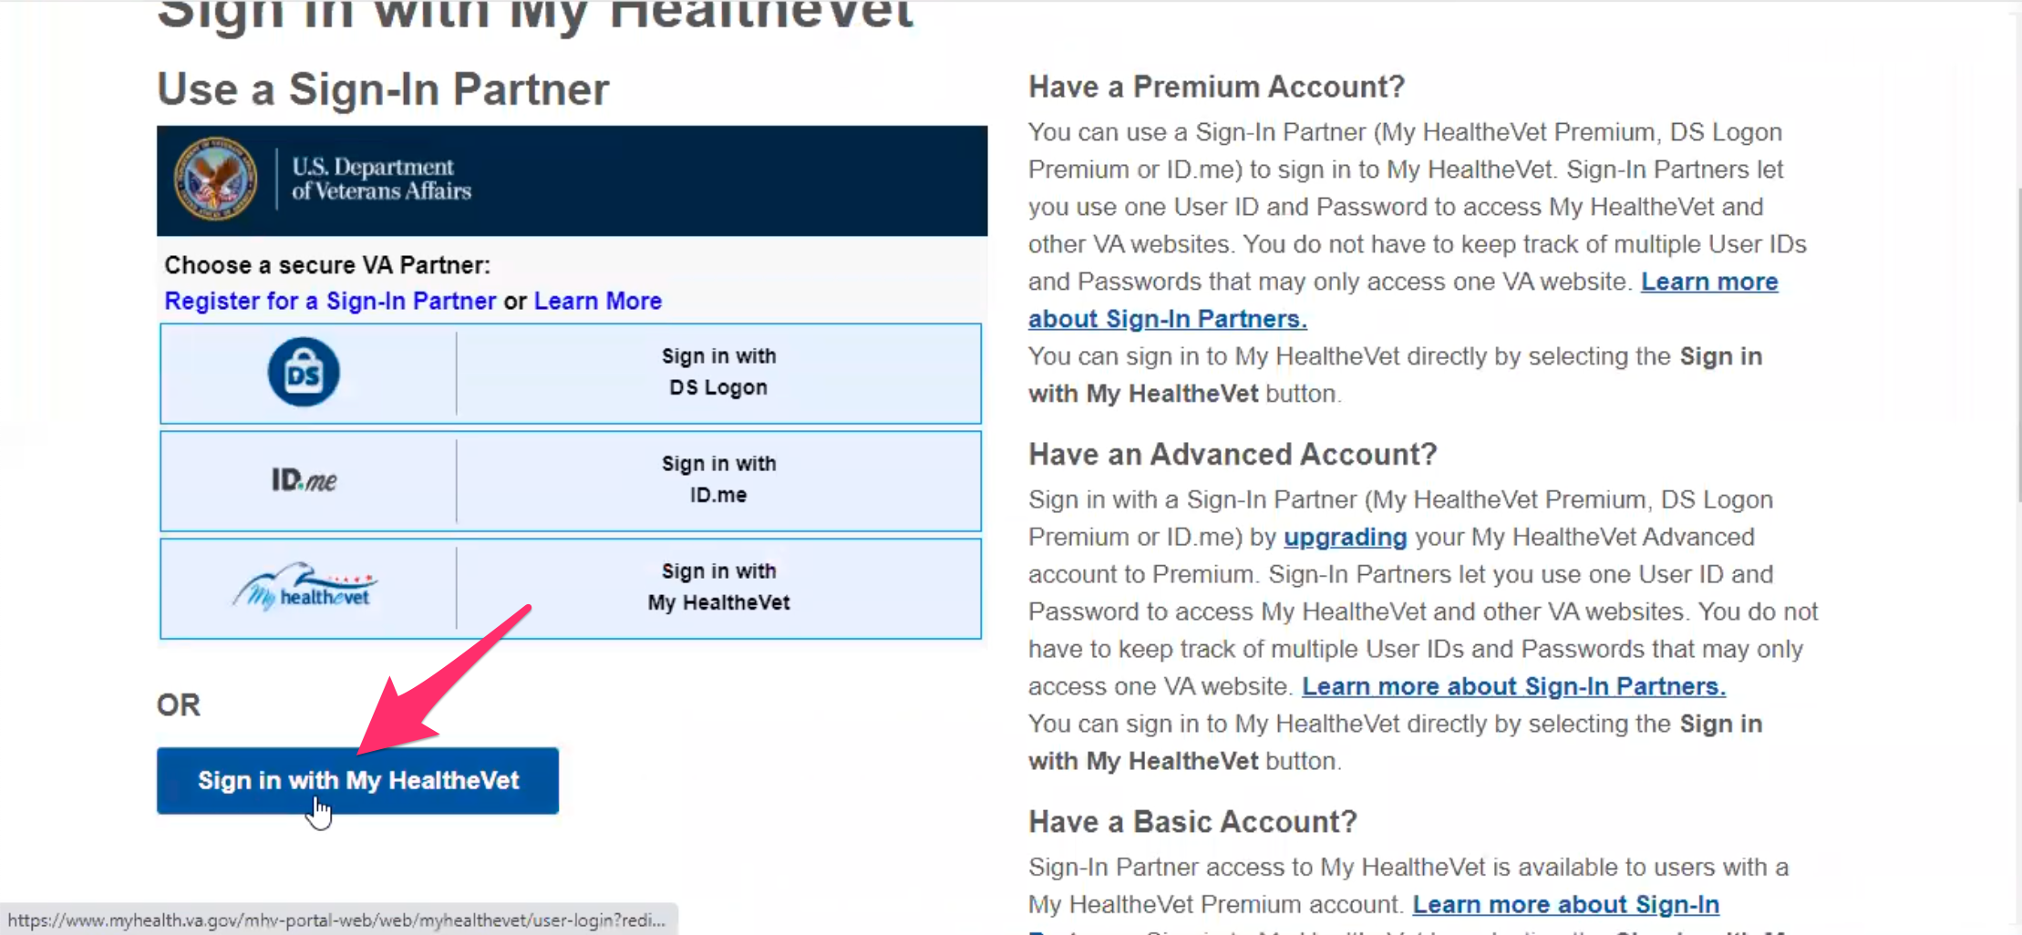

Participant chooses blue “Sign in with My HealtheVet” button at the bottom of the page.

Sign in with My HealtheVet.

Occasionally it pops up. *Participant is referring to having form fields autofill in sign in form*.

I haven’t logged in with this one in a while so I might have to look up the password.

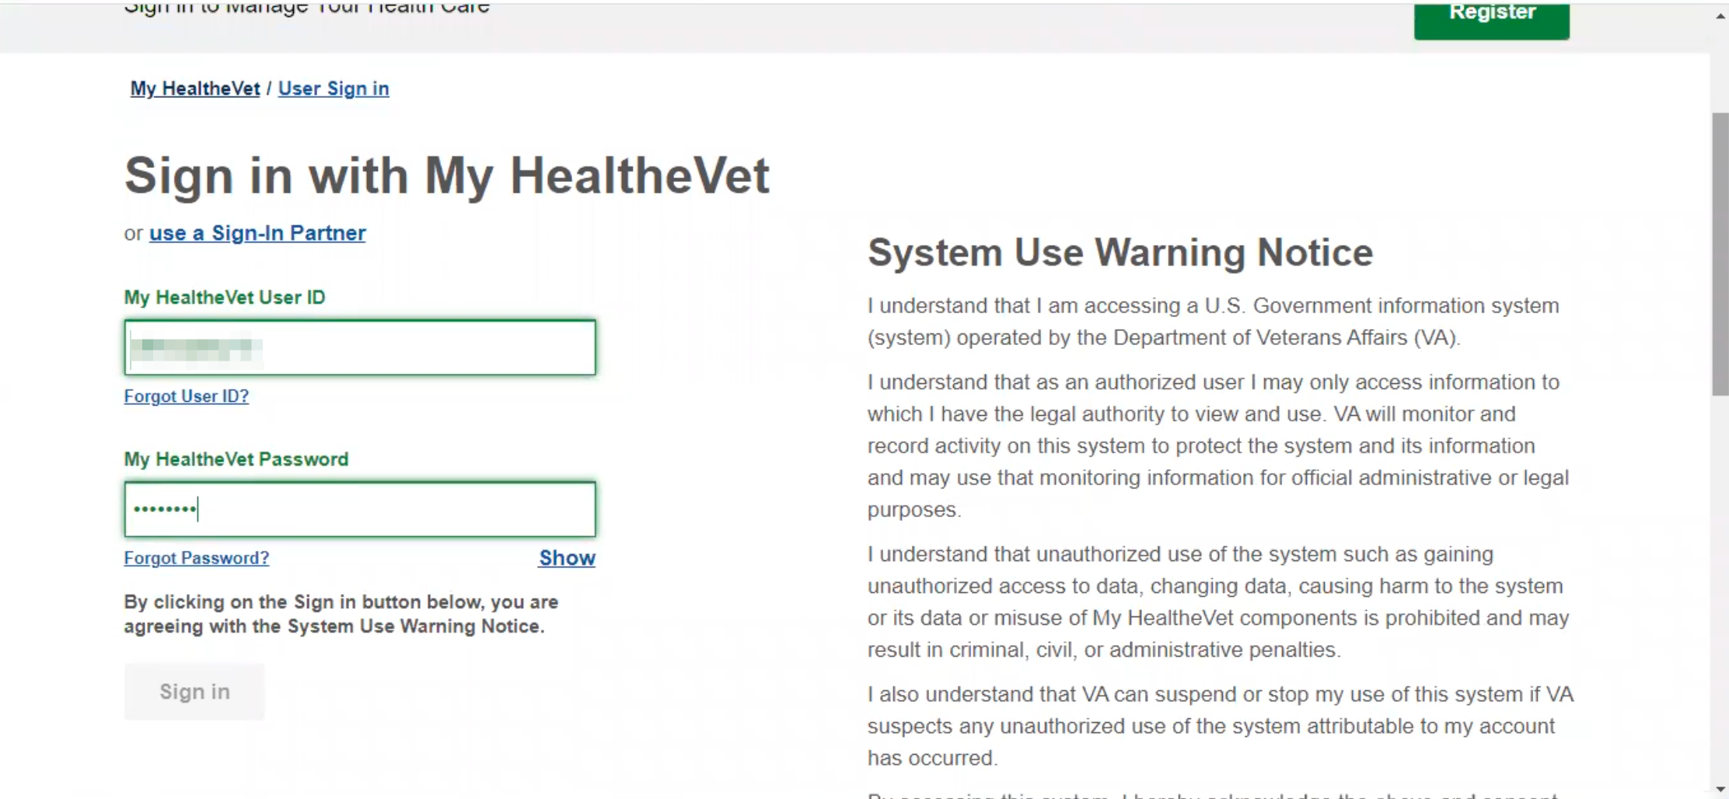

Participant fills out form into My HealtheVet. Form fields have green outline for focus/active state.

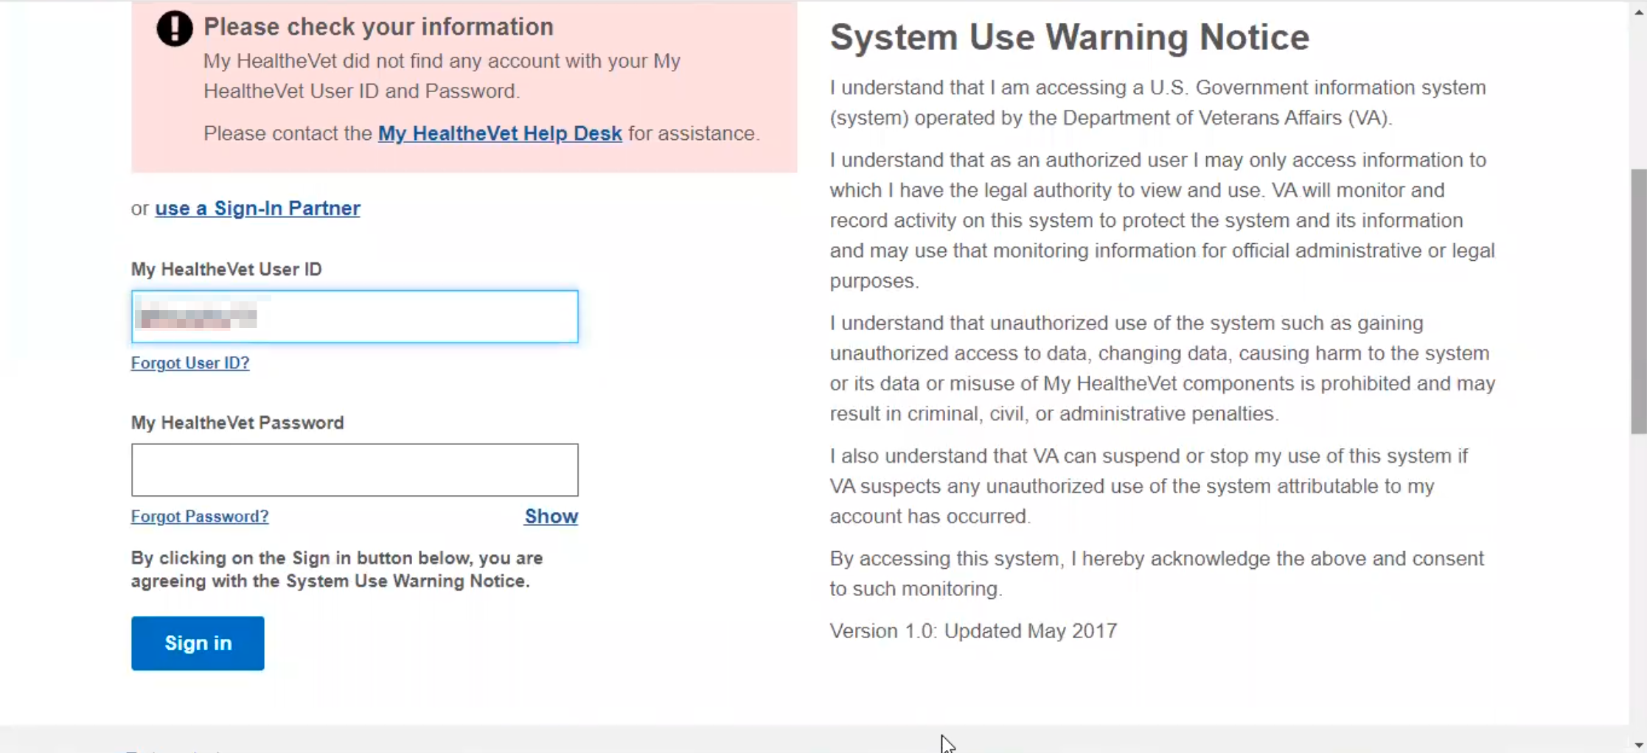

Participant gets error message saying User ID or Password is incorrect.

Normally I would go through our document with all of his logins, we call them Army logins. I am going to look it up on my phone. If I didn’t have a document I would forget them.

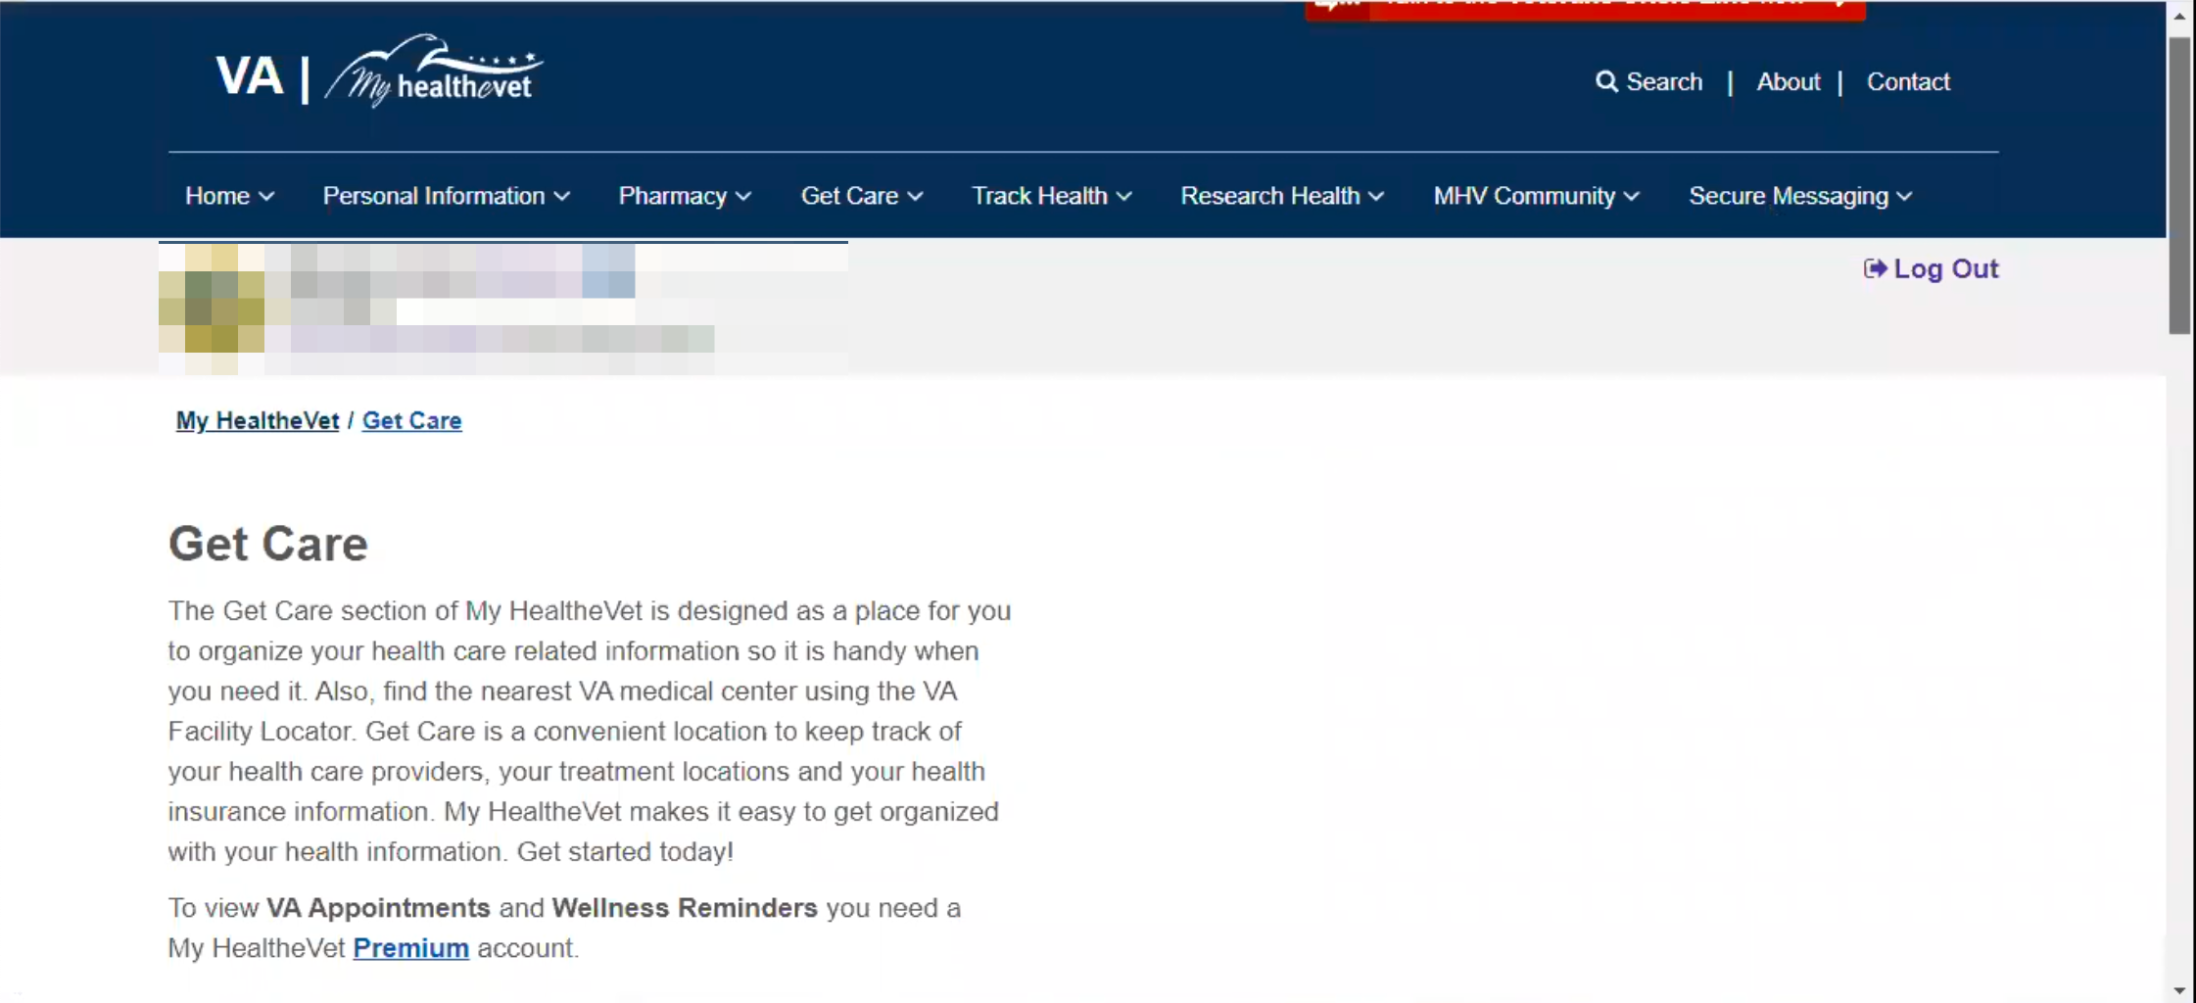

Participant successfully logs in.

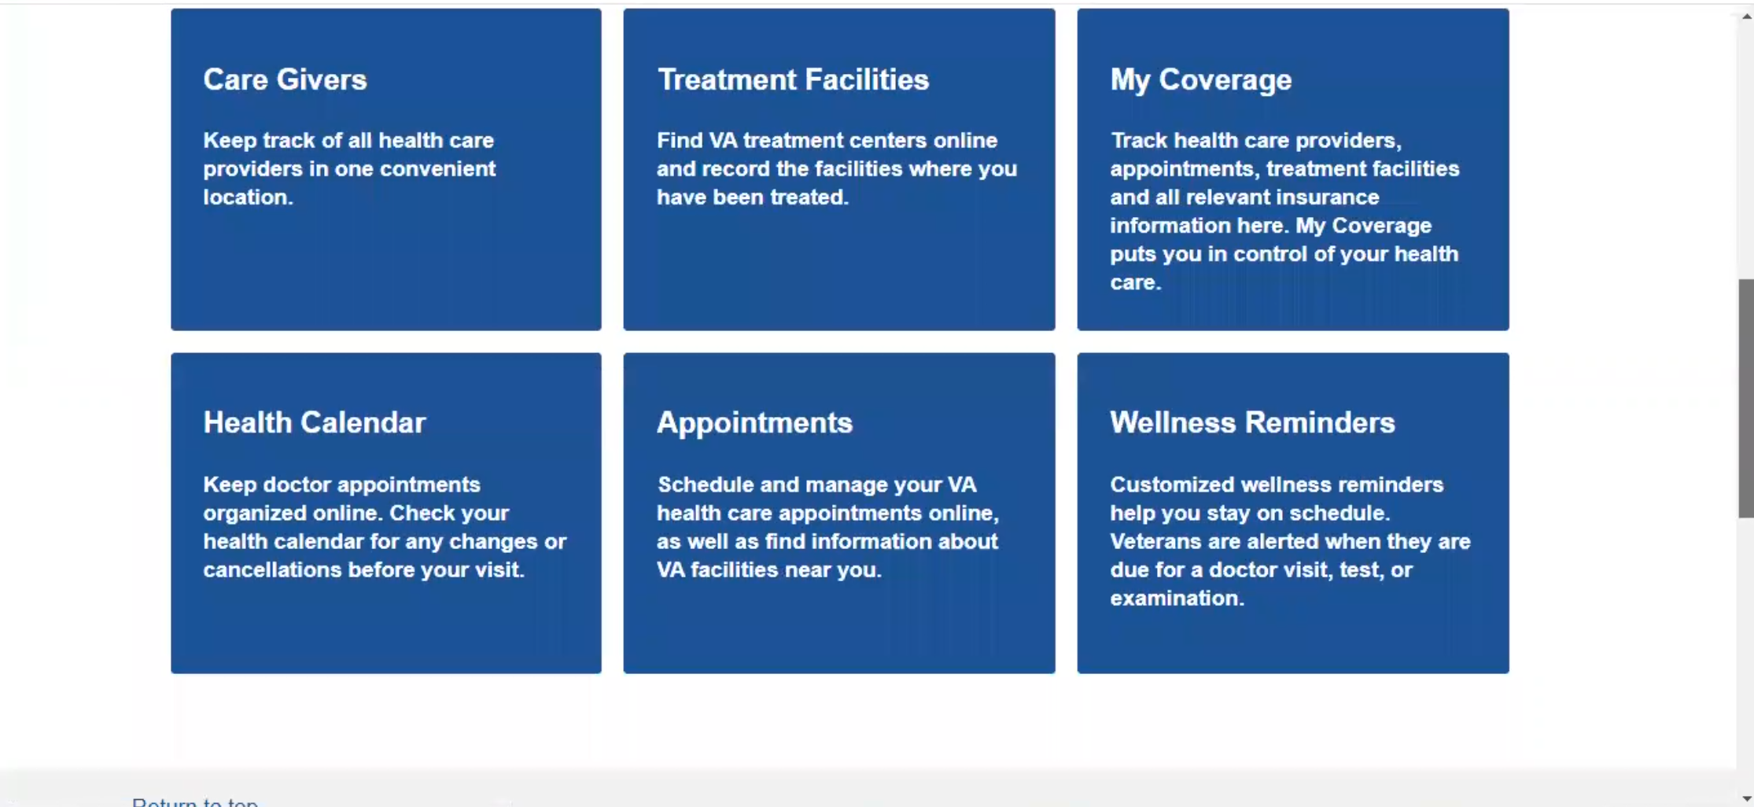

Participant scrolls down to bottom of the page.

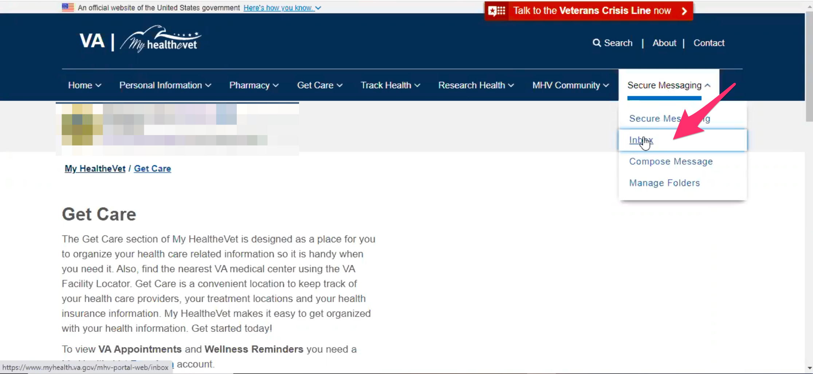

Participant scrolls back to top of the page. Looks through the main navigation for several seconds before hovering over “Secure Messaging” and clicking “Inbox” in submenu drop down.

I go to secure messaging and check the inbox to see if anything is in there.

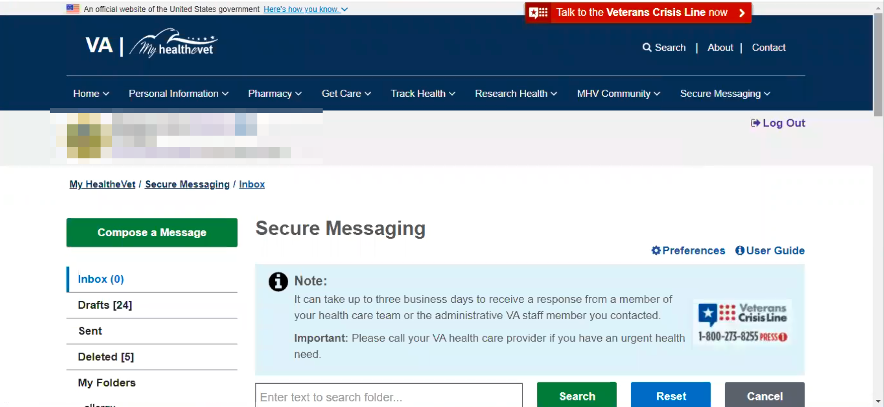

Inbox page loads.

We message a lot and I have this broken to the different ailments to the folders on the left.

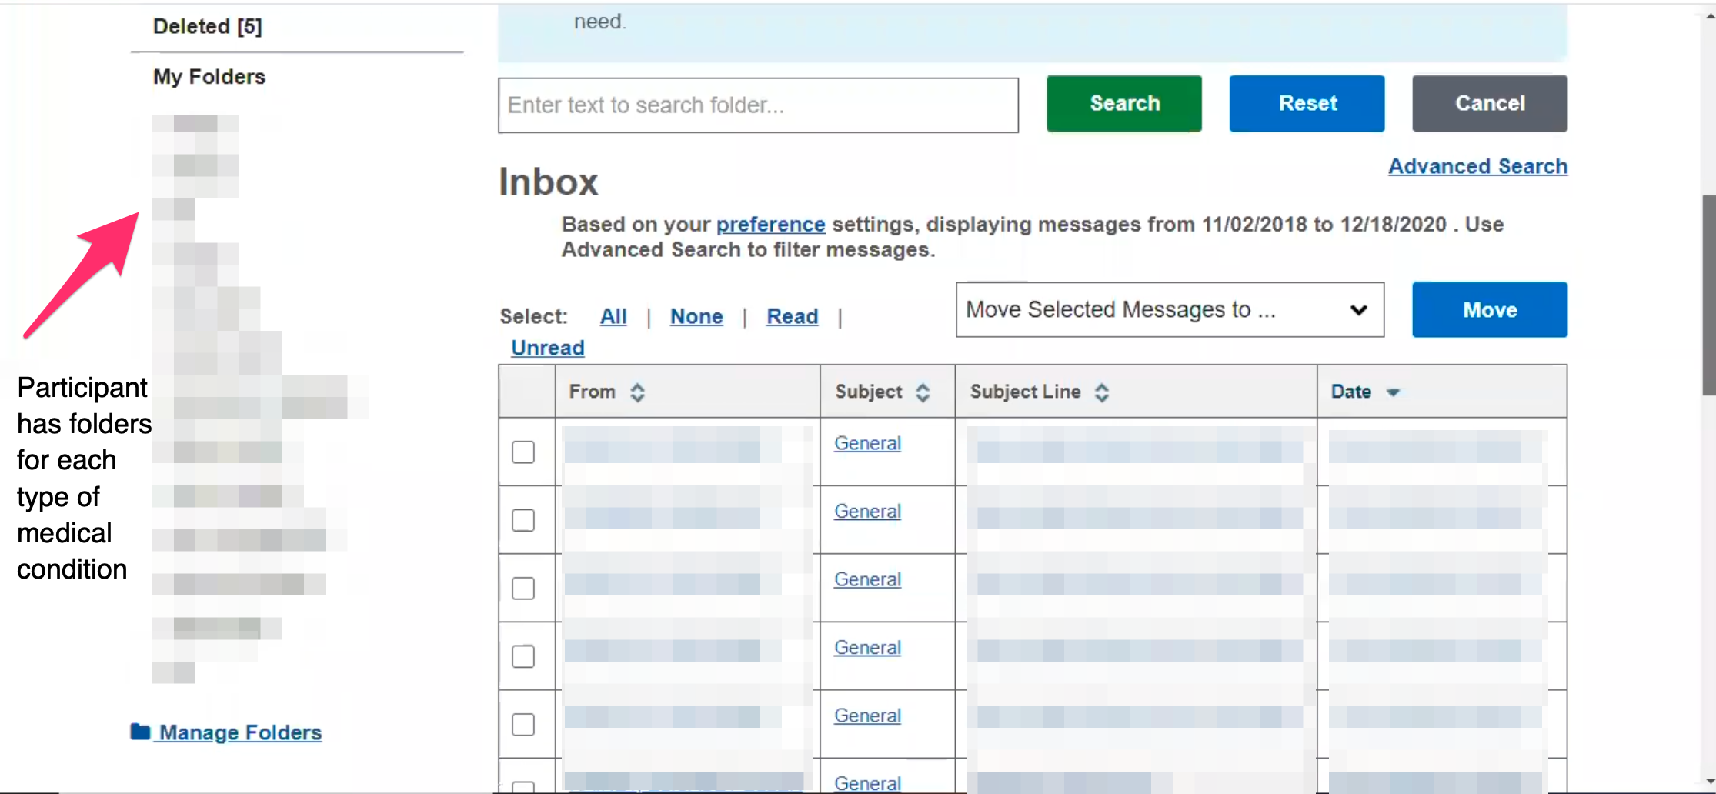

Participant scrolls down and points out how they use folders organizes messages by each type of medical condition

Yeah over here, they are all broken down, and they are all still in the inbox but it makes it easier to find.

We have had a lot of issues with the shower chair. They sent the wrong one. It started in September and got it fixed at the end of November. *Participant is talking about the subject line of many of the messages in the inbox.*

We had to back track over the emails and then they could see when it started. That it had taken a long time it’s time to get it taken care of and was able to over night it. I don’t know why that couldn’t happen in the first. We had to get new referrals sent out, new PT appointments. We like the PT at Greenville he is a great guy. Finally got an appointment with him. He said I’ve seen you a million times lets just get this taken care of. But it feels like we jumped through hoops to get it done.

**For messaging only shows a certain amount of messages at a time. Curious how does that work for you:**

I think it’s fine. If I need to filter things out I can go down here and pull them all up. *Participant is talking about setting the number of messages to display to 200.*

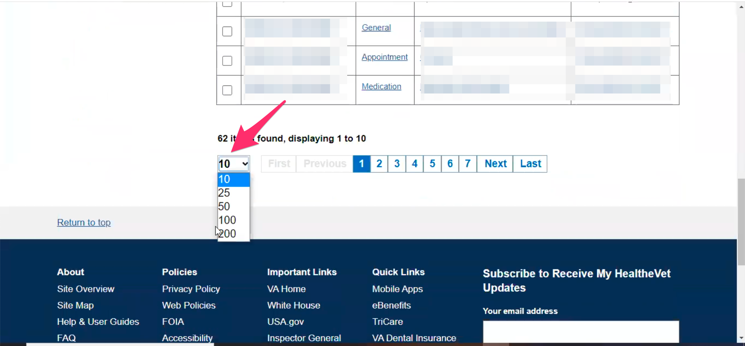

Participant points out ability to select how many message display on a page.

I can show a lot of them. I do go in and delete the ones that are irrelevant every once in a while.

So pretty much every one that you see here has a good response to it and not just a generic I’ll tell the doctor response.

I try to keep them all in the email cycle. Each one might have a few drop downs on, which you can see.

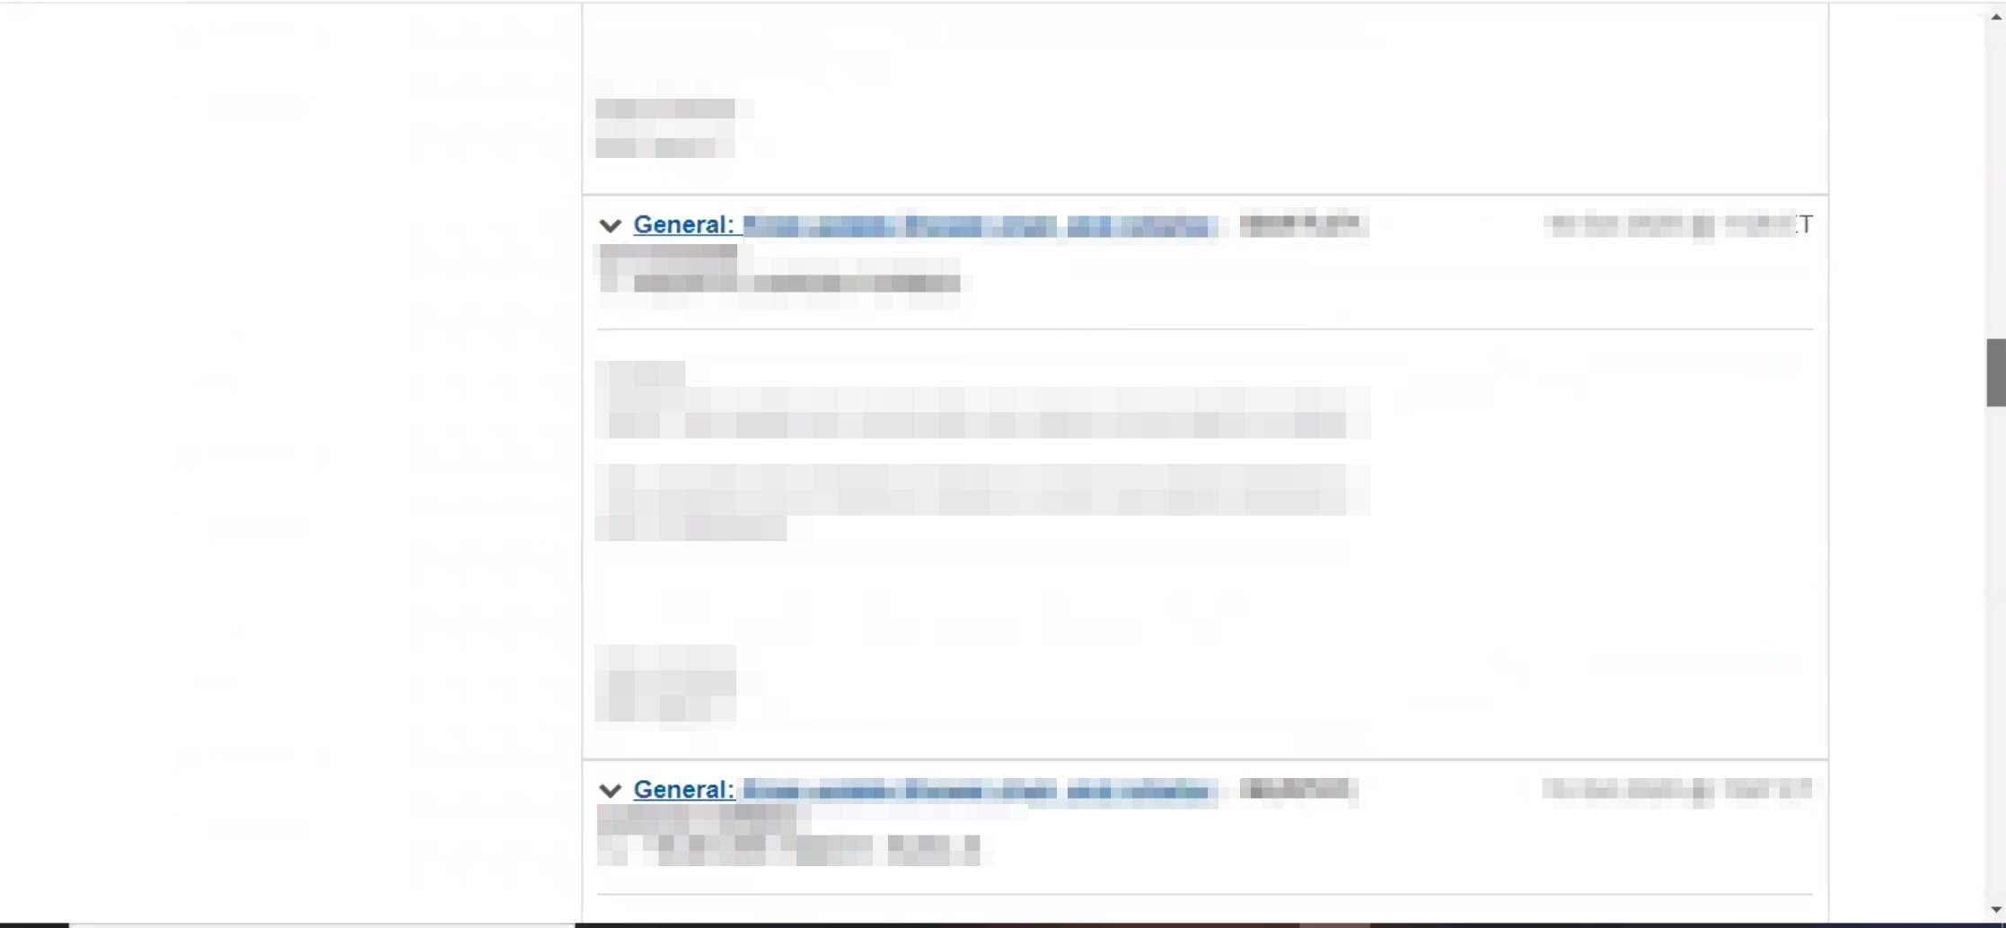

Participant clicks into a specific message and shows the thread of the message.

It can be months of emails back and forth.

Typically if I sign them you will see this instead. *Participant show that she signs message with “[Full Name] Caregiver Spouse for [Veteran’s Full Name] Retired US ARMY”*

If my husband signs it he is very abrasive with his emails. I am more informational. He is more straight to the point.

Some are these are just copy and paste, reiterating.

Most of them look like this. Multiple back and forths. Here we are clearing up miss communications.

We use it as a great tool to say this is what we need and what we need corrected.

This one is all about [equipment]. *Participant is referring to message they are showing.* We called and talked to them so we told them again what we needed after not hearing back for weeks. I try to be polite with it because that gets a whole lot more done. You can see we do recaps of what we did before.

I use this system a lot. We probably annoy the providers a little but this past year has been very up in the air. There’s a lot of moving pieces. So for him with infectious disease, he got one post op. So he has a civilian infectious disease and the VA infection disease. The civilian doctors has to send it to the VA for approval for medication to be sen out. So he technically has two infectious disease providers who are going through primary care. There is a lot of people that need to work together to process his care let along get it provided.

I try to get the processing side done so the providers can do their job better.

One of my jobs is I connect the dots. So who needs to talk to who. A lot times VA health doesn’t even realize an order is going through until it hits their desk. And they are the last ones to see it.

So I usually give them a heads up. And it gets the process going a lot easier.

I had had issues of having to get the referral from Community Health, they were able to back track it up the cycle to find the paperwork they needed within 10 minutes. Other routes it could have taken 3-4 weeks to get it completed.

I ran medical clinics before so I think it helps my side. I can see how the pieces should work a little easier. I try to help. I don’t know if I do. *Participants laughs.*

If his health is stalled then our house is stalled. We like moving pieces but I like to at least have information on the next step so we are not stuck in a blackhole limbo because we didn’t follow up.

The providers have hundreds if not thousands of patients, so if we don’t follow up they are bound to forget, it is human nature. If we can keep our issues in the fore front, I find that we get more corrected. We are patient but we like to make sure the pieces are moving.

**How well does sharing the account work or anything that a challenge, especially with email who is signing what:**

For me I sign it differently. I used to sign it all under his and that would get confusing. We kind of had a heart to heart with primary care so she knows she is emailing me and not him. She laughed about it. I said I’ll start signing it that way you know. That was about 2.5 years ago that I started signing as caregiver.

She noticed the tones changed in the email. Participant laughs. Some were really thought out and others were more concise. He is more concise. I learned that they forget the original conversation was. And he thinks they should remember. So it works fine.

Typically we navigate the email together. Most of the time I will write myself and then ask if he agrees. If not then we edit it but most of the time he says okay.

Every once in a while I see one where drops in an email email. I think his phone finally saved his password. For a long time he couldn’t get on for the longest because he couldn’t remember the password or where to find the password.

I like to see what we both follow up on so the provider doesn’t get bombarded with multiple emails. I can close chapters as they are getting closed.

The one that we don’t do much is deep writing back and forth with mental health. It’s mostly medications with that one. I try to leave that to his safe zone. If we need to talk we ask for an appointment so his issues aren’t in writing. Issues aren’t a good word.

Everyone else we give pretty good detail.

**Thank you and closing (2 minutes)**

**Feedback**: I don’t think. I can’t think of one.